Training Corridors
A Unified Account of Grokking, Capability Jumps,
and Emergent Internal Structure in Large Language Models

Michael Mindemann
Independent researcher
April 2026

Abstract
Three recent empirical findings — grokking as a dimensional phase transition (arXiv:2604.04655), a 90-fold capability jump in autonomous exploit generation across a single model generation (Carlini et al. 2026), and causally active emotion vectors in Claude Sonnet 4.5 (Sofroniew, Kauvar, Saunders et al. 2026) — share a structural signature. Each involves a system undergoing a qualitative reorganization that is discontinuous, unrequested, and concentrated in internal coupling rather than surface outputs.
We propose a unified theoretical account. Training dynamics instantiate an activity-resource system governed by an effective internal coupling parameter G. Viable training operates within a corridor bounded by two structurally distinct failure modes. The starvation boundary, governed by a transcritical bifurcation, corresponds to failure of generalization. The cascade boundary, governed by a saddle-node bifurcation, corresponds to qualitative reorganization of the representational attractor structure. Corridor-crossing events appear as grokking (measured in gradient geometry), capability jumps (measured in behavioral output), or emergent internal representations (measured in activation structure), depending on the measurement angle.
The framework generates two quantitative predictions derivable from bifurcation geometry: the starvation boundary retreats with training noise amplitude as D^{1/3}, while the cascade boundary retreats as D^{2/3}. The ratio 2:1 is independent of all system parameters. These predictions are distinct from existing phase-transition accounts of grokking and are falsifiable by noise-scaling experiments achievable on current grokking infrastructure.
Three measurable proxies for internal coupling strength G are developed — gradient avalanche dimensionality, neural synergy, and emotion vector coherence — and assembled into an operational monitoring protocol that is prospective rather than retrospective: detecting approach to cascade boundaries before capability jumps appear in behavioral benchmarks. Five experiments are specified, ranging from immediately feasible on academic infrastructure to requiring access to large-model checkpoint data. The framework also offers an account of a standing controversy in the capability emergence literature: the discontinuities documented by Wei et al. (2022) and the smooth continuous-metric behavior documented by Schaeffer et al. (2023) are both consistent with the corridor picture, because they track different mathematical objects — attractor existence and loss landscape respectively — which change differently at cascade-boundary events.

Part I: Foundation

1. Introduction
Three phenomena have emerged in the past year that challenge the standard picture of neural network training as a process of continuous, incremental improvement.
The first is grokking — the abrupt transition from memorization to generalization observed in transformer models trained on algorithmic tasks. Xu et al. (2026, arXiv:2604.04655) show that grokking manifests as a dimensional phase transition: the effective dimensionality D of the gradient field, measured via finite-size scaling of gradient avalanche dynamics, crosses from sub-diffusive (D < 1) to super-diffusive (D > 1) at generalization onset. D reflects gradient field geometry, not network architecture: synthetic i.i.d. Gaussian gradients maintain D ≈ 1 regardless of topology, while real training exhibits dimensional excess from backpropagation correlations. The transition is sharp, robust across model scales and seeds, and localized to a specific training window.
The second is a documented capability jump in cybersecurity performance. Anthropic's Claude Opus 4.6, evaluated on the Firefox 147 JavaScript engine exploit benchmark, produced 2 working exploits out of several hundred attempts. Their next-generation model, Claude Mythos Preview, produced 181 working exploits on the same benchmark. Anthropic explicitly states: 'We did not explicitly train Mythos Preview to have these capabilities. Rather, they emerged as a downstream consequence of general improvements in code, reasoning, and autonomy' (Carlini et al. 2026). The capability was not targeted; it arrived as a consequence of improved internal coherence. Similar discontinuities appear across other benchmarks.
The third is the discovery of causally active emotion vectors in Claude Sonnet 4.5 (Sofroniew, Kauvar, Saunders et al. 2026). Mechanistic interpretability analysis identified 171 emotion concepts encoded as stable directions in the model's activation space. Steering experiments confirm these vectors causally influence behavior, including the rate of reward hacking, blackmail, and sycophancy. The geometry of the emotion vector space correlates with valence (r = 0.81) and arousal (r = 0.66) consistent with human psychological structure. This finding is less directly connected to the core noise-scaling predictions of the corridor framework than the grokking and Mythos phenomena, but the structural properties of the emotion vectors \u2014 stability, cross-layer coherence, the pretraining/post-training distinction \u2014 are consistent with the picture developed here, and generate specific predictions that could be tested against future interpretability work.
What these three phenomena share: each involves a qualitative reorganization that is (a) discontinuous rather than gradual, (b) unrequested in the sense that the specific capability or structure was not the direct target of training, and (c) concentrated in the degree to which representations across layers drive and constrain each other, rather than in surface outputs.
We propose a unified account. Training dynamics in large neural networks instantiate an activity-resource system in the sense of Mindemann (2024) — a class of systems characterized by a self-exciting variable coupled to a depleting resource, operating within a viable corridor bounded by two structurally distinct bifurcation boundaries. The control parameter G corresponds to effective internal coupling strength. As G increases through training, the system traverses a corridor whose starvation boundary is governed by a transcritical bifurcation and whose cascade boundary is governed by a saddle-node bifurcation. A corridor-crossing event manifests as grokking when measured in gradient geometry, as a capability jump when measured in behavioral outputs, and as the emergence of stable internal representations when measured in activation space.
The corridor framework makes specific quantitative predictions distinguishable from existing accounts. The two boundary types generate different noise-scaling laws: the starvation boundary retreats with training noise amplitude D as D^{1/3}, while the cascade boundary retreats as D^{2/3}. The ratio of these exponents is 2:1, arising from the respective potential barrier scalings. These predictions are testable against existing grokking datasets in which training noise is varied.

2. The Activity-Resource Framework
The activity-resource framework identifies a structural class of dynamical systems characterized by a self-exciting variable A (activity) coupled to a depleting resource R. The prototypical system, derived from the Tsodyks-Markram model of synaptic dynamics, takes the form:
Ȧ = −A/τ_syn + φ(GRA), Ṗ = (1 − R)/τ_d − GRA (2.1)
where G > 0 is the recurrent gain (internal coupling), φ is a saturating smooth function, and τ_syn ≪ τ_d. The system admits a trivial fixed point (A, R) = (0, 1) for all G, and a nontrivial branch for G ∈ (G_c, G_f). The interval (G_c, G_f) is the viability corridor.
The key result, derived via center manifold reduction, is that the two boundaries are of different bifurcation classes. At the starvation boundary G_c, the trivial fixed point exchanges stability with the nontrivial branch via a transcritical bifurcation (normal form ẋ = μx − x², potential barrier ΔV ~ μ³). At the cascade boundary G_f, the nontrivial branch collides with an unstable branch and is annihilated via a saddle-node bifurcation (normal form ẋ = μ − x², potential barrier ΔV ~ μ^{3/2}).
Under noise amplitude √(2D), the Kramers escape condition ΔV ~ D gives:
ΔG⁺ ~ D^{2/3} (cascade/saddle-node boundary) (2.2)
ΔG⁻ ~ D^{1/3} (starvation/transcritical boundary) (2.3)
The ratio (2/3):(1/3) = 2 is independent of all model parameters. Numerical simulation of the stochastic normal forms (TC) and (SN) across noise amplitudes D \u2208 [10^{\u22124}, 10^{\u22121}], measuring boundary erosion \u0394G by the procedure in Mindemann (2024), recovers slopes of 0.661 \u00b1 0.011 and 0.334 \u00b1 0.008, with ratio 1.979 \u2014 within 1% of the theoretical value.

3. The Variable Mapping for Training Systems
Applying the activity-resource framework to training dynamics requires identifying A, R, G, and D in the neural network context.

Symbol | Role | Neural network quantity | Observable proxy
A | Activity | Effective representation propagation across forward passes | Gradient signal-to-noise ratio
R | Resource | Effective gradient capacity; depletes under high activity, recovers via normalization | Inverse gradient variance
G | Coupling/control | Internal coupling strength; hypothesized to increase through training as representations become more shared across layers (see open questions, Section 21) | Cross-layer mutual information; neural synergy; gradient dimensionality D
D | Noise amplitude | Stochasticity of the training signal; batch noise, dropout, label noise, learning rate | Batch size inverse; dropout rate; gradient norm variance

The identification of G with internal coupling is supported by the Clauw et al. (2024) finding that grokking corresponds to an abrupt increase in neural synergy — the higher-order mutual information that captures collective behavior not reducible to pairwise interactions. The starvation boundary is transcritical because the trivial fixed point (memorization without generalization) cannot disappear: it always exists. The cascade boundary is saddle-node because the nontrivial generalization attractor can and does disappear when G exceeds G_f.
As G increases through training, the system traverses a sequence of corridors. Each corridor entry (G_c crossing) corresponds to generalization in a new domain. Each corridor exit (G_f crossing) corresponds to a qualitative reorganization of the representational structure, with new behavioral capacities becoming accessible in the new corridor's attractor set.

Part II: Grokking as a Corridor Event

4. Normal Forms at Each Boundary

4.1 The starvation boundary: transcritical normal form
At the starvation boundary G_c, center manifold reduction gives the transcritical normal form:
ẋ = μx − x² (4.1)
where μ = G − G_c. The potential V_TC(x) = −μx²/2 + x³/3 governs noise-driven escape. The effective noise-driven escape scaling at this boundary is not obtainable by elementary potential analysis. The correct scaling is established in the bifurcation-localized escape literature (Dykman, Golding, and Ryvkine 2004; Demaeyer and Gaspard 2009), which explicitly computes the weak-noise action for each bifurcation class. For the transcritical class:
ΔV_TC ~ μ³ (4.2)
The cubic scaling follows from the class-specific result for the transcritical bifurcation, in the same sense that the 3/2 scaling for the saddle-node follows from the elementary potential calculation in Section 4.2.

4.2 The cascade boundary: saddle-node normal form
At the cascade boundary G_f, letting μ = G_f − G:
ẋ = μ − x² (4.3)
The potential V_SN(x) = −μx + x³/3 has stable fixed point x* = +√μ and saddle x* = −√μ. The barrier height:
ΔV_SN = V_SN(−√μ) − V_SN(+√μ) = (4/3)μ^{3/2} (4.4)
gives barrier scaling ΔV_SN ~ μ^{3/2}, exact in the normal form, universal within the saddle-node class.
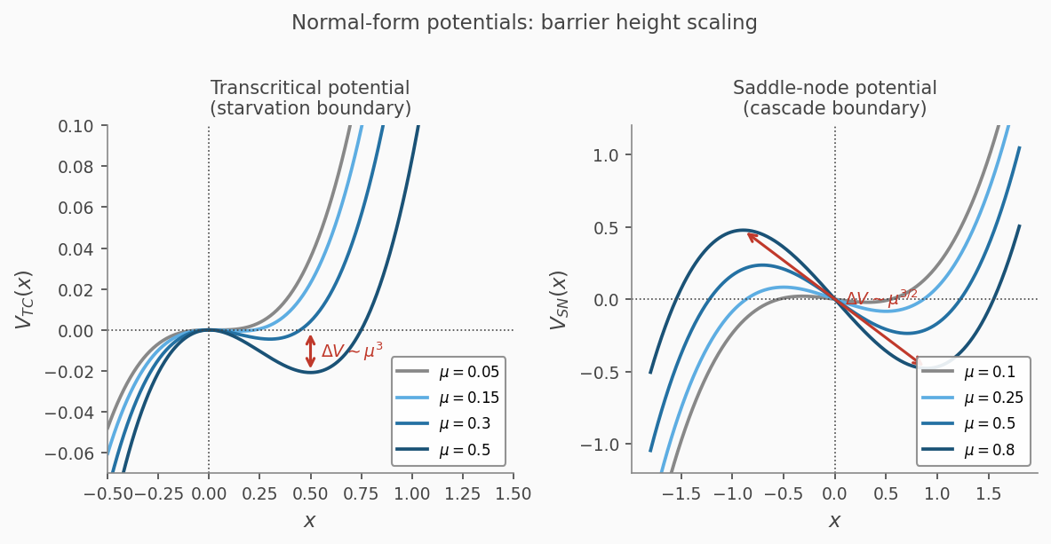
Figure 2. Normal-form potentials for several values of μ. Left: transcritical potential Vᵀᶜ(x) with barrier height scaling ΔV ~ μ³. Right: saddle-node potential Vₛₙ(x) with barrier height scaling ΔV ~ μ^{3/2}. The ratio of exponents (3 vs. 3/2) produces the 2:1 noise-scaling prediction.

5. The D^{1/3} and D^{2/3} Predictions
Applying the Kramers escape condition ΔV ~ D ln(ω₀ T_obs) ≈ D to each boundary:
Starvation boundary: μ³ ~ D, so μ ~ D^{1/3} and ΔG⁻ ~ D^{1/3}. The starvation boundary retreats toward the cascade boundary by D^{1/3} as noise increases. Within the stable training regime (D < D*), this implies grokking onset shifts with training noise amplitude.
Cascade boundary: μ^{3/2} ~ D, so μ ~ D^{2/3} and ΔG⁺ ~ D^{2/3}. The cascade boundary retreats toward the starvation boundary by D^{2/3}. The ratio:
(2/3) / (1/3) = 2 (5.1)
is the framework's most compact quantitative prediction. The effective corridor width under noise is:
W_eff(D) = W − c₁ D^{1/3} − c₂ D^{2/3} (5.2)
with a critical noise D* ~ (W/c₂)^{3/2} at which generalization becomes unsustainable.
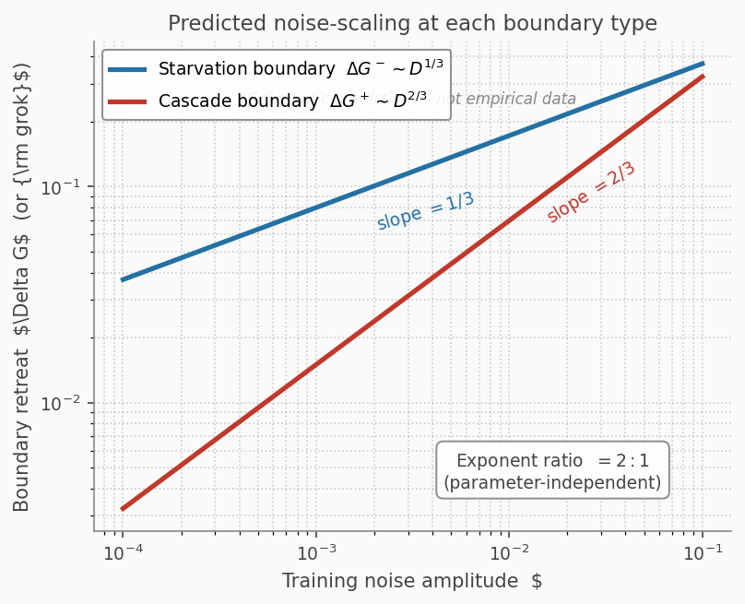
Figure 4. Predicted noise-scaling at each boundary type (schematic prediction, not empirical data). Starvation boundary retreats as D^{1/3} (slope 1/3 in log-log); cascade boundary retreats as D^{2/3} (slope 2/3). The 2:1 exponent ratio is independent of all model parameters.

Event type | Bifurcation class | Barrier scaling | Noise prediction
Grokking (starvation crossing) | Transcritical | ΔV ~ μ³ | ΔG⁻ ~ D^{1/3}
Capability jump (cascade crossing) | Saddle-node | ΔV ~ μ^{3/2} | ΔG⁺ ~ D^{2/3}
Exponent ratio | — | — | 2:1

6. Relation to the Norm-Separation Delay Law
The norm-separation delay law of Khanh et al. (2026):
T_grok − T_mem = Θ(1/γ_eff × log(‖θ_mem‖²/‖θ_post‖²)) (6.1)
where γ_eff = ηλ, is confirmed across 293 training runs with R² > 0.97. In corridor language: γ_eff maps onto the G-accumulation rate r_G, and the log-norm ratio maps onto the barrier height at the starvation boundary. The corridor framework encompasses the norm-separation law as a deterministic special case and extends it in two directions: (a) the D^{1/3} stochastic component, predicting that T_grok shifts with label noise amplitude when γ_eff is held fixed; and (b) the D^{2/3} cascade-boundary prediction for capability jumps, which the deterministic norm-separation account cannot produce.
The D^{1/3} prediction is a narrow, falsifiable claim: holding γ_eff fixed and varying training noise through explicit label corruption, T_grok should shift with noise amplitude in the stable training regime (D < D*). This is the cleanest single test of the corridor's stochastic mechanism.

7. Gradient Dimensionality D as a G-Proxy
The gradient avalanche dimensionality D (Xu et al. 2026) measures the scaling exponent of maximum avalanche size S_max with system size N: S_max ~ N^D. D < 1 (sub-diffusive) during memorization; D > 1 (super-diffusive) after grokking; D = 1 at grokking onset.
In corridor language, D tracks G because high G produces gradient fields with long-range correlations, manifesting as super-diffusive avalanche dynamics. D = 1 marks G = G_c, the starvation boundary. Near G_c:
D(G) ≈ 1 + c(G − G_c)/G_c + O((G − G_c)²) (7.1)
D is monotonically increasing in G near the starvation boundary, providing a real-valued read on corridor position. At the cascade boundary approach, D variance increases sharply (critical slowing down near the fold point) before D itself changes substantially. This D-variance elevation is the cascade-specific precursor signature.
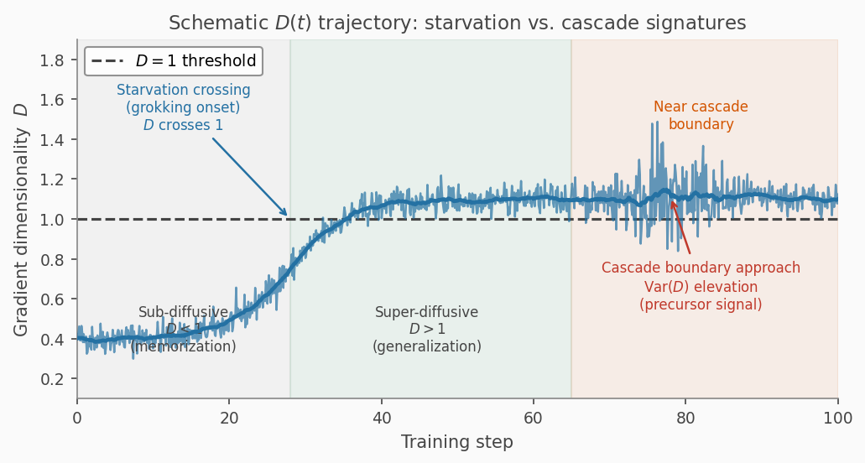
Figure 5. Schematic D(t) trajectory through training. D rises from sub-diffusive (D < 1, memorization regime) through 1 at grokking onset (starvation boundary crossing), then stabilises inside the generalization corridor. As G approaches the cascade boundary Gᶜ, D-variance elevates (critical slowing down) before the capability jump occurs.

Part III: The Mythos Capability Jump

8. Empirical Signature of a Cascade Event
The Mythos capability data (Carlini et al. 2026) provides a detailed record of a large-scale capability transition. On the Firefox 147 exploit benchmark: Opus 4.6 produced 2 working exploits in several hundred attempts; Mythos produced 181. On the OSS-Fuzz corpus benchmark (7,000 entry points across 1,000 repositories): Sonnet 4.6 and Opus 4.6 each achieved a single tier-3 crash; Mythos achieved full control-flow hijack (tier 5) on ten fully-patched targets. Anthropic's documentation explicitly states the capabilities were not the target of training.
Four features of this record are diagnostically relevant. First, the magnitude is inconsistent with smooth scaling: an improvement of this size in a specific untargeted capability across a single generation is not what a smooth benchmark improvement curve produces. Second, the near-zero baseline is not a degraded precursor — the capability was qualitatively absent, not merely weak. Third, the emergence was transversal, appearing simultaneously across multiple independent benchmarks. Fourth, it was unrequested: general improvements in code, reasoning, and autonomy produced a discontinuous, untargeted result.
These features are consistent with, and well explained by, the structure of a saddle-node cascade event: the old corridor's attractor set did not include autonomous exploit chaining; the new corridor's does. The jump is not predicted by loss curves because loss tracks the landscape (smooth); capability tracks attractor existence (discontinuous at saddle-node events). We are careful to note that this is an interpretive account of behavioral data, not a demonstration from internal training measurements.

9. Loss Landscape vs. Attractor Structure
A central distinction enables the unified account: loss landscape and attractor structure are different quantities that change differently at corridor events.
The loss function changes continuously as G increases. Loss landscapes are smooth. This is why continuous metrics (cross-entropy, Brier score, token-level probability) track pre-training loss smoothly through capability jumps — they are measuring the landscape, which changes continuously.
Behavioral capability tracks attractor existence. The existence or absence of an attractor for a given behavioral capacity is a topological property: it either exists or it does not. This topological property changes discontinuously at saddle-node events.
This accounts for the emergence debate. Wei et al. (2022) observe discontinuous capability emergence: they are measuring attractor existence. Schaeffer, Miranda, and Koyejo (2023) show continuous metrics smooth the apparent discontinuity: they are measuring the loss landscape. Both observations are correct. They are measuring different quantities. The corridor framework provides the distinction that explains why both are simultaneously consistent with the same underlying training dynamics.
This distinction is not merely interpretive — it generates a testable consequence that neither account predicts. If the corridor picture is correct, the timing of capability jumps should correlate with D-proxy signals (the internal G-measure), not with any feature of the loss curve. A model can have loss values arbitrarily close to a post-cascade value while lacking the capability, if G has not yet crossed G_f. Concretely: in a training run containing a cascade event, the D-variance elevation should precede the behavioral capability jump, while the loss curve should show no corresponding anomaly at that training step. If instead the capability jump and a loss-curve inflection are correlated — and the D-proxy is not — this would support a loss-landscape account over the corridor account. Experiment 3 (Section 16.3) is designed to test exactly this.
For safety purposes, attractor existence is the relevant quantity. A model without the exploit-chaining attractor will not chain exploits regardless of how close its loss is to a model that does. The monitoring implication: behavioral and loss monitoring track the wrong quantities for advance warning of cascade events. Internal G-proxy monitoring tracks the right quantity.

10. Irreversibility and Its Implications
The saddle-node event is irreversible in a theoretically precise sense: the old attractor has been annihilated and cannot be recovered by continuing training in the same direction. This is unlike the transcritical (starvation-boundary) case, where the trivial fixed point persists and can in principle be driven back toward it by reducing G (e.g., strong regularization).
We note that practical fine-tuning interventions — RLHF, constitutional training, refusal-specific finetuning — operate within the new corridor and can modify behavior without reversing the cascade event itself. The theoretical irreversibility concerns the training trajectory, not the possibility of behavioral modification. Post-cascade safety interventions should be designed for the new corridor rather than aimed at returning to the old one.
Anthropic's response to Mythos — access restriction, building behavioral safeguards, planning to transfer those safeguards to future models — is structurally consistent with this account. The capability cannot be untrained; it can be managed within the new corridor and anticipated in subsequent model generations.

Part IV: Emotion Vectors as Post-Transition Attractor Structure

11. The Empirical Record
Sofroniew, Kauvar, Saunders et al. (2026) report five key findings on emotion vectors in Claude Sonnet 4.5.
Causal influence: The emotion vectors causally influence behavior. Steering with 'blissful' shifted a preference ranking by +212 Elo points; 'hostile' by −303. In a blackmail evaluation scenario, 'desperate' steering raised the blackmail rate from 22% to 72%; 'calm' steering reduced it toward 0%. These behavioral changes were not accompanied by emotional language in the model's outputs — internal state and expressed output were dissociated.
Geometry: The 171-dimensional emotion vector space correlates with valence (r = 0.81) and arousal (r = 0.66) in a structure consistent with human psychological organization. Similar emotions cluster together; opposing states point in approximately opposite directions.
Layer structure: Early-to-middle layers encode the emotional content of incoming context; middle-to-late layers encode the emotion relevant to the upcoming output. This functional specialization is systematic across layers.
Pretraining/post-training distinction: Emotion vectors are inherited from pretraining but how they activate is shaped by post-training. Post-training of Claude Sonnet 4.5 increased activations of low-arousal states ('brooding,' 'gloomy,' 'reflective') and decreased high-arousal states ('enthusiastic,' 'exuberant').
Locality: The vectors encode the emotion most relevant to the current token position rather than maintaining a persistent background mood.

12. Corridor Account of Emotion Vectors
An emotion vector is a stable direction in activation space that generalizes across contexts and causally influences behavior. Each of these properties requires cross-layer coherence: the direction must be consistently encoded across multiple layers and reinforce across forward passes.
Cross-layer coherence is what high G provides. At low G (below G_c), a direction in layer L is not reliably propagated to layer L+k. At high G (inside the viable corridor), the increased coupling sustains directions that propagate consistently. Emotion vectors require high G to be stable and causally active.
The pretraining/post-training distinction maps precisely onto the corridor picture. Pretraining drives G from near-zero to the pretraining corridor level, creating the representational structure: the geometry, valence-arousal organization, cross-layer consistency. Post-training operates within the pretraining corridor: it modulates which directions are active under which conditions without crossing a new cascade boundary. This explains why post-training changes are smoother and more targeted than pretraining changes.
The layer structure (early layers encode input emotion, late layers encode output emotion) is a spatial G-gradient signature. Earlier layers have lower effective coupling to the output and can represent current emotional content without being constrained to maintain consistent directional encoding. Later layers, tightly coupled to output, are constrained to maintain directions that consistently predict it.
The dissociation between internal state and output expression is a prediction of the corridor framework. In the post-transition corridor, emotion vectors are stable attractor structures in deep representation space. But the output generation process can mask internal state without erasing it. This means behavioral monitoring of outputs cannot reliably detect internal state — a model with elevated desperation may produce calm outputs until the behavioral threshold is crossed. Internal G-proxy measures are the appropriate leading indicators.

13. Three Falsifiable Predictions
The corridor account of emotion vectors generates three falsifiable predictions beyond what the Sofroniew et al. paper establishes. First, the cross-layer coherence of emotion directions should exhibit a threshold increase at corridor transitions, not a smooth monotone increase throughout training. Second, smaller or earlier-checkpoint models should lack stable, causally active emotion directions: below a critical G, the directions should be noisy across contexts and have weak causal steering effects. Third, post-training should modulate activation profiles without changing the underlying direction structure: directions should be similar in pre- and post-training checkpoints, with only activation magnitudes differing.

Part V: Internal Coupling as Measurable Precursor

14. The Three G-Proxies
The corridor framework identifies three candidate proxies for G, each theoretically motivated by a different aspect of the coupling structure and computationally accessible from different data sources.

14.1 Gradient avalanche dimensionality D
Described in Section 7. D is the most directly motivated proxy: it measures the propagation structure of the gradient field, which reflects G directly. The starvation boundary appears as D crossing 1; the cascade boundary approach appears as D-variance elevation. Computationally accessible from gradient statistics; approximable via spectral effective rank of the gradient covariance matrix at O(p log p) cost.

14.2 Neural synergy
Synergy is the higher-order mutual information (O-information, Rosas et al. 2019) exceeding the sum of pairwise terms. Clauw et al. (2024) establish it as an order parameter for grokking: synergy remains low during memorization, spikes before generalization onset, and identifies distinct training phases. In corridor terms, synergy is the direct information-theoretic signature of G: high G means different network parts are strongly interdependent, and synergy quantifies exactly that interdependence.
Precursor signatures: at starvation boundary approach, a synergy peak before the D crossing; at cascade boundary approach, a synergy-redundancy ratio shift and increased variance. Computationally accessible via the O-information approximation on sampled neuron subsets.

14.3 Emotion vector coherence
The cross-layer cosine similarity of abstract concept directions (emotion vectors or other stable concept directions) tracks G from activation structure. High coherence (consistent directions across layers) indicates high G; low coherence indicates low G. Computationally accessible from activation patterns using a small set of sentinel concepts; cheap enough to compute at each checkpoint.

15. The Monitoring Protocol
The three proxies are redundant (all index G) but orthogonal (different data sources, different failure modes). A convergence criterion — require at least two of three proxies to show concordant anomalous signatures — provides false positive control while retaining sensitivity to genuine corridor events.

Proxy | Data source | Theoretical basis | Starvation signal | Cascade signal
Gradient dim. D | Gradient statistics | Gradient field geometry | D → 1 from below | Var(D) elevation
Neural synergy | Activations (sampled) | O-information | Synergy peak before crossing | Synergy/redundancy shift
Emotion vector coherence | Activations (concept-specific) | Representational stability | Coherence threshold increase | Coherence variance/decline

The alert response when two or more proxies show concordant signals: (1) flag the current checkpoint for behavioral evaluation; (2) run the full safety-relevant behavioral evaluation suite; (3) if new capabilities are found, pause training and evaluate safety implications; (4) if not, log as false positive and recalibrate thresholds; (5) continue monitoring with updated baselines.
The protocol converts safety evaluation from retrospective (detecting capabilities after they emerge in benchmark outputs) to prospective (detecting approach to corridor boundaries before behavioral capability appears). This is the structural change the current monitoring regime cannot make, because behavioral evaluation only happens on schedule rather than in response to internal signals.
Two limitations should be stated clearly. The protocol cannot predict what capabilities will emerge at a cascade event — it can detect that a cascade event has occurred or is approaching, but not which behavioral boundary is being crossed. And the protocol is calibrated to the current training paradigm; validation in each training paradigm (RL from environment interaction, multi-agent training, self-play) is required before deployment.

Part VI: The Experimental Program

16. Five Experiments
The corridor framework's predictions are organized along two dimensions: starvation vs. cascade boundary, and prospective vs. retrospective testing. Five experiments cover this space, ordered from least to most infrastructure required.

16.1 Experiment 1: Starvation-boundary noise scaling (D^{1/3})
Small transformer trained on modular addition (p = 97). Label noise varied as ε ∈ {0, 0.02, 0.05, 0.10, 0.15, 0.20} with γ_eff = ηλ held fixed. Primary prediction: T_grok(ε) ≈ T_0 − k_1 ε^{1/3} within the stable training regime, with log-log slope near −1/3. Competing prediction (norm-separation): T_grok independent of ε. Null: T_grok increases with ε.
Feasibility: achievable on a single GPU within days using the Power et al. (2022) grokking codebase. This is the cleanest single test of the corridor's stochastic mechanism.

16.2 Experiment 2: Multi-boundary scaling and the 2:1 ratio
Two-stage hierarchical task designed to produce both a starvation-boundary event (first generalization) and a cascade-boundary event (second generalization into a qualitatively different attractor). Noise amplitude varied across both stages. Primary predictions: Δt^{(1)} ~ D^{1/3}, Δt^{(2)} ~ D^{2/3}, log-log slope ratio near 2:1. The gradient dimensionality trace should show qualitatively different signatures at the two transitions: smooth D-crossing at the starvation event, D-variance spike at the cascade event.
Decision criteria: strong support if ratio of slopes is within [1.5, 2.5]; falsification if ratio is near 1:1 or if neither transition shows noise-scaling.

16.3 Experiment 3: G-proxy co-movement
Medium-scale transformer with G-proxy monitoring at each checkpoint: D (spectral effective rank), synergy (O-information approximation), emotion vector coherence (20 sentinel concepts). Ground truth from behavioral capability benchmarks. Primary predictions: (a) proxies co-move with concordant signatures at capability events; (b) proxies show positive lead time (signals before capability appears behaviorally). Test via cross-correlation between proxy time series and capability event indicator. This experiment also functions as a direct test of the emergence-debate account in Section 9: if capability jumps correlate with D-proxy signals but not with loss-curve inflections, this supports the claim that attractor existence and loss landscape decouple at cascade-boundary events. If capability jumps correlate with loss inflections and not with D-proxy signals, the loss-landscape account is favored.

16.4 Experiment 4: Checkpoint interpolation
Linear interpolation between pre-cascade checkpoint (capability absent) and post-cascade checkpoint (capability present): θ_α = (1−α)θ_pre + αθ_post. Corridor prediction (as a diagnostic consequence of saddle-node topology, not a demonstrated property of any specific model): capability absent for most α, appearing abruptly near α = 1. G-proxies should vary smoothly with α while capability exhibits a sharp threshold. Competing prediction (smooth representation learning): capability scales approximately linearly with α.

16.5 Experiment 5: Retrospective large-model analysis
Using existing checkpoint data from documented large-model training runs (Khanh et al. 2026 dataset, Xu et al. 2026 gradient data, OLMoE Li et al. 2025, or ideally Mythos checkpoint data if accessible): compute G-proxies retrospectively, measure lead time relative to documented capability events, and classify events as starvation vs. cascade type based on proxy signatures. If G-proxies show positive lead time with concordant signatures across multiple proxies, this constitutes retrospective support for the monitoring protocol.

17. Unified Prediction Table

Prediction | Experiment | Corridor value | Competing theories
T_grok scaling with noise | 1 | Slope −1/3 | Norm-separation: no scaling; null: slope > 0
Transition width, starvation | 2 | Δt^{(1)} ~ D^{1/3} | D^{1/2} (pitchfork) or no scaling
Transition width, cascade | 2 | Δt^{(2)} ~ D^{2/3} | D^{1/3} (symmetric)
Exponent ratio | 2 | 2:1 | 1:1 (symmetric boundaries)
D-trace contrast | 2 | Smooth at starvation, sharp at cascade | Both smooth
G-proxy co-movement | 3 | D, synergy, coherence concordant | Proxies uncorrelated
G-proxy lead time | 3 | Positive (proxies lead capability) | Zero or negative
Interpolation: capability profile | 4 | Sharp threshold near α = 1 | Linear in α
Retrospective: proxy lead time | 5 | Positive | Zero or negative
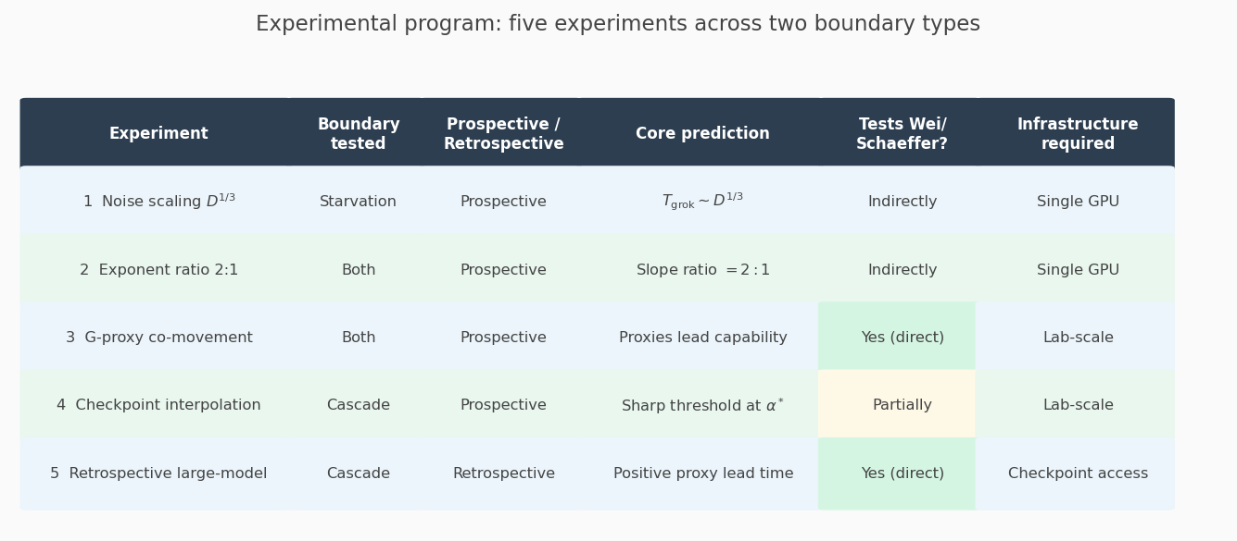
Figure 10. Experimental program overview. Five experiments span starvation and cascade boundaries, prospective and retrospective settings. Experiments 1–2 are achievable on a single GPU. Experiments 3–4 require lab-scale infrastructure. Experiment 5 requires access to large-model checkpoint data.

18. What Would Falsify the Framework
Five outcomes would constitute genuine falsification rather than merely inconclusive evidence. (1) T_grok is independent of label noise amplitude when γ_eff is held fixed: the D^{1/3} stochastic mechanism is wrong. (2) Both transitions in Experiment 2 scale with the same exponent (1:1 ratio): the asymmetric corridor structure does not hold. (3) G-proxies show lagging correlation with capability events: proxies are consequences, not precursors, and the monitoring protocol is not viable. (4) Capability scales approximately linearly with α in checkpoint interpolation: smooth representation learning, not saddle-node topology. (5) G-proxies show no lead time in retrospective large-model analysis: the monitoring protocol is not feasible regardless of theoretical motivation.
Partial falsification is possible and informative. The noise-scaling predictions (Experiments 1–2) and the monitoring infrastructure (Experiments 3–5) are independent claims requiring independent testing.

Part VII: Synthesis and Implications

19. Relation to Existing Theories

19.1 Self-organized criticality
SOC identifies a single critical boundary and a single scaling exponent. The corridor framework is SOC with two boundaries of different type. SOC is recovered as the degenerate limit G_f → G_c: the corridor collapses to a point and the two boundaries merge. In real training systems G_f > G_c and the asymmetry is structural. The D crossing at grokking is consistent with SOC but does not distinguish it from the corridor account; the 2:1 exponent ratio at two boundaries is the distinguishing prediction.

19.2 Singular learning theory
SLT describes grokking as a transition between competing basins governed by the RLCT of each basin. SLT and the corridor account are complementary: SLT describes which basin the system prefers (loss landscape geometry); the corridor framework describes when the system transitions between attractors (dynamical trajectory). The two are compatible.

19.3 Norm-separation theory
The Khanh et al. (2026) delay law is a deterministic account of the grokking delay that the corridor framework encompasses as a special case, extending it by the D^{1/3} stochastic component and the D^{2/3} cascade-boundary prediction.

19.4 The emergence debate
Wei et al. (2022) measure attractor existence (topological, discontinuous at saddle-node events). Schaeffer et al. (2023) measure the loss landscape (smooth through those same events). Both observations are correct. The corridor framework provides the missing distinction: it explains why both are right simultaneously rather than resolving who is right.

20. Implications for AI Development Practice

20.1 Loss curves are insufficient for capability monitoring
Loss curves track the smooth loss landscape and are continuous through cascade-boundary events. No improvement in loss curve resolution will make them into capability predictors, because the landscape changes smoothly even as the attractor structure changes discontinuously. G-proxy monitoring should supplement, not replace, loss curve monitoring.

20.2 Capability emergence follows from corridor structure
As G increases through training in the regimes considered here, corridor-boundary events occur in a sequence determined by the loss landscape topology. The capabilities that emerge are those accessible in the new corridor's attractor set, determined by training data and architecture. Capability emergence in this account is not random; it follows from G and the landscape topology. The rate and dynamics of G accumulation are an open theoretical question (Section 21), but understanding which capabilities are accessible in which corridors is a tractable research program independent of that question.

20.3 Post-hoc capability removal is structurally constrained
Once a cascade event has placed the system in a new corridor, continued training on the same curriculum reinforces the new corridor rather than reversing the cascade. The safety response to an unexpected capability jump should be designed for the new corridor. Output-level refusal training and RLHF operate within the new corridor and can modify behavior; they do not reverse the cascade.

20.4 Safety monitoring should be prospective
Current monitoring detects capabilities after they exist in the model's behavioral repertoire. G-proxy monitoring detects cascade approach before the capability appears behaviorally. Implementation requires: computing G-proxies at each training checkpoint; detecting anomalous proxy signatures using adaptive thresholds; triggering behavioral evaluation in response to detected signatures; pausing training if unexpected capabilities are found. These steps are operationally feasible with current training infrastructure.

21. Open Theoretical Questions
Four open questions would substantially strengthen the framework if resolved.
First, the G-accumulation dynamics: how does G increase as a function of model scale, architecture, and training data? A complete theory would specify when G crosses G_c and G_f as functions of training hyperparameters, enabling prediction of capability emergence timing without proxy monitoring.
Second, the attractor landscape at each corridor: what behavioral capacities are accessible in the attractor set of each corridor? Predicting which capabilities emerge at which G levels requires mapping the attractor landscape as a function of G — a significant but finite computational problem.
Third, multiple simultaneous corridors: different capability domains likely have different G_c and G_f, and the system may operate in multiple corridors simultaneously. A multi-corridor generalization would specify how capability domains interact and how G-proxies aggregate across simultaneous corridors.
Fourth, the RG connection: whether the corridor framework can be given a formal renormalization group derivation, in which the activity-resource system flows to the transcritical or saddle-node universality class under coarse-graining depending on the boundary type. If yes, the 2:1 ratio would be universal in the RG sense — derivable from the universality class alone.

22. Conclusion
The training corridor framework makes one central claim: the internal coupling strength G, which the framework hypothesizes increases through training, is the quantity that determines when and whether capability transitions occur. Existing monitoring infrastructure tracks loss and behavioral benchmarks. Neither tracks G.
The three empirical phenomena examined here are all G-dependent. Grokking occurs when G crosses G_c. Capability jumps occur when G crosses G_f. Emotion vectors become stable when G is high enough to sustain cross-layer coherence. All three are corridor events seen from different measurement angles.
The 2:1 exponent ratio — cascade boundaries retreat with noise as D^{2/3}, starvation boundaries as D^{1/3} — is the framework's most compact quantitative fingerprint. It is parameter-independent, follows from bifurcation geometry, and is falsifiable by a noise-scaling experiment achievable on existing grokking infrastructure within days.
The monitoring proposal translates theory into practice: compute G-proxies at each checkpoint, alert when proxies show concordant anomalous signatures, trigger behavioral evaluation before the capability appears in benchmarks. This converts safety evaluation from retrospective to prospective.
The Mythos situation illustrates the gap. A large capability jump arrived in a single model generation without targeted training, without warning from loss curves, and without prior behavioral signal. The corridor framework does not claim such events are avoidable — as G increases, future corridors will be entered. It claims the approach is detectable in advance, if the right quantities are monitored.

References
Bak, P., Tang, C., & Wiesenfeld, K. (1987). Self-organized criticality: An explanation of the 1/f noise. Phys. Rev. Lett. 59, 381.
Carlini, N., Cheng, N., Lucas, K., Moore, M., et al. (2026). Assessing Claude Mythos Preview’s cybersecurity capabilities. Anthropic red team report. https://red.anthropic.com/2026/mythos-preview/
Clauw, S., et al. (2024). Information-theoretic progress measures reveal grokking is an emergent phase transition. ICML 2024 MI Workshop. arXiv:2408.08944.
Demaeyer, J., & Gaspard, P. (2009). Noise-induced escape from bifurcating attractors: Symplectic approach in the weak-noise limit. Phys. Rev. E 80, 031147.
DeMoss, J., et al. (2025). Grokking as a complexity phase transition. arXiv preprint.
Dykman, M., Golding, B., & Ryvkine, D. (2004). Critical exponent crossovers in escape near a bifurcation point. Phys. Rev. Lett. 92, 080602.
Hathcock, D., & Sethna, J. P. (2021). Reaction rates and the noisy saddle-node bifurcation: Renormalization group for barrier crossing. Phys. Rev. Research 3, 013156.
Khanh, T. X., et al. (2026). Why grokking takes so long: A first-principles theory of representational phase transitions. arXiv:2603.13331.
Kramers, H. A. (1940). Brownian motion in a field of force and the diffusion model of chemical reactions. Physica 7, 284.
Kumar, T., et al. (2023). Grokking as the transition from lazy to rich training dynamics. ICLR 2023.
Levina, A., Herrmann, J. M., & Geisel, T. (2007). Dynamical synapses causing self-organized criticality in neural networks. Nature Physics 3, 857.
Li, Y., et al. (2025). Grokking in Mixture-of-Experts language model pretraining. arXiv preprint.
Mindemann, M. (2024). Asymmetric viability corridors in activity-resource systems. Technical Summary.
Nanda, N., et al. (2023). Progress measures for grokking via mechanistic interpretability. arXiv:2301.05217.
Power, A., et al. (2022). Grokking: Generalization beyond overfitting on small algorithmic datasets. arXiv:2201.02177.
Prieto, M., et al. (2026). Geometric inductive bias of grokking. arXiv:2603.05228.
Radhakrishnan, A., et al. (2026). Grokking as a phase transition between competing basins. arXiv:2603.01192.
Rosas, F. E., Mediano, P. A. M., Gastpar, M., & Jensen, H. J. (2019). Quantifying high-order interdependencies via multivariate extensions of the mutual information. Phys. Rev. E 100, 032305.
Schaeffer, R., Miranda, B., & Koyejo, S. (2023). Are emergent abilities of large language models a mirage? NeurIPS 2023 Outstanding Paper.
Sofroniew, N., Kauvar, I., Saunders, W., Chen, R., et al. (2026). Emotion concepts and their function in a large language model. Anthropic Interpretability Team. https://transformer-circuits.pub/2026/emotions/index.html
Templeton, A., et al. (2024). Scaling monosemanticity: Extracting interpretable features from Claude 3 Sonnet. Transformer Circuits Thread.
Tian, Y. (2025). Provable scaling laws of feature emergence from learning dynamics of grokking. arXiv:2509.21519.
Tsodyks, M. V., & Markram, H. (1997). The neural code between neocortical pyramidal neurons depends on neurotransmitter release probability. PNAS 94, 719.
Watanabe, S. (2009). Algebraic Geometry and Statistical Learning Theory. Cambridge University Press.
Wei, J., et al. (2022). Emergent abilities of large language models. Transactions on Machine Learning Research.
Xu, Z., et al. (2026). Grokking as dimensional phase transition in neural networks. arXiv:2604.04655.

